Hello, my name is….
Romy Bressers
2TTA1
15-09-2015
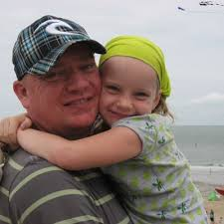
My name is Romy, I’m 13 years old and I go to the Beatrix college. I’m in the second year of TTO, I get all of my lessons in English. I live with my mother, my parents are divorced. I have 2 brothers but they both live somewhere else, they are 24 and 25. I like meeting up with friends, drawing and my biggest hobby is watching, the walking dead. The walking dead is a series about a virus that turns you into a zombie when you die or get bitten. I’m a huge Beyoncé fan because her voice is so powerful and her music just speaks to me a lot. I’ve had an open heart surgery as baby and I still have a big scar from it, I was in hospital for a very long time but everything is all right now. In the weekends I don’t do much, I usually just hang out with friends or sleep in.

