Drugs
Also drugs can be seen as vandalism, we found different articles about drugs that have been found. These articles are written in different years from 2012 till 2015. Also the ages of the dealers are different.
For example the following article about drugs which is been found during a neighbourhood action of the police. The drugs were found in a house, this was during an action were more than 17 houses were invested. The police had some anonymous tips about drug dealers and drug plantations, some of the tips they used others they questioned.
My opinion:
I think drugs aren’t acceptable, also soft drugs (which are allowed in the Netherlands) aren’t ok: it’s unhealthy and you can get addicted which isn’t a good thing neither.
I do think that drugs are vandalism, cause of it being something that has to happened top secret and is against the laws or rules.

Parents and vandalism
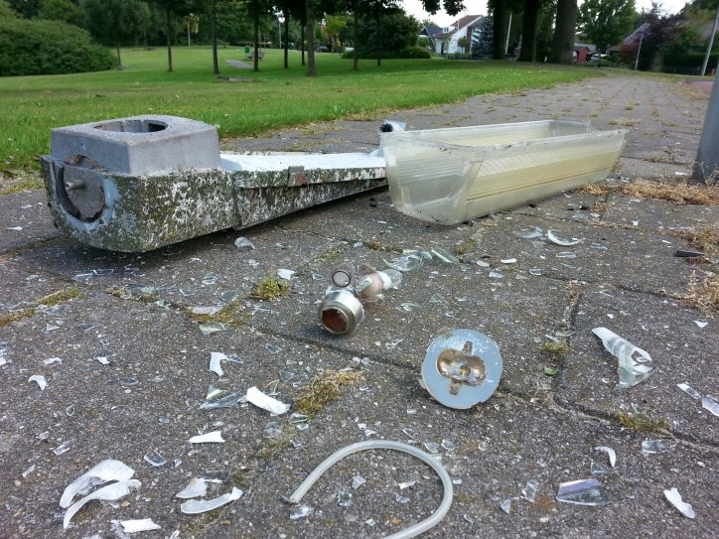
Also we found an article about parents and vandalism. If a daughter or son from under the 18 years, ruins for example street light (on purpose ). Do the parents have to pay that? The politics (in the Netherlands) don’t think so. They decided that parents aren’t responsible for the damage a child delivers. Some people think this isn’t the right decision, they say that it’s a part of the upbringing of the parents.

My opinion:
I think that didn’t make a good decision , parents are responsible for the upbringing of their children and also for the damage till a certain point.

