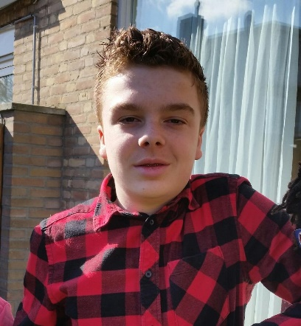
Hello, my name is…
Hello, I am Lars Bierens and I am 13 years old. I live in the Netherlands with my parents, my little sister, my dog and my 2 rabbits. At home I like play monopoly with my parents and little sister.

Hobbies
My hobbies are football, gaming and hang out with my friends. My favourite football club is PSV Eindhoven. I play also football by myself. I play it at Gudok in the team C6. Mostly I play as central defender. The games I like the most are FIFA and GTA because they are the best games ever made. What I like the most is hanging out with my friends because we always have a lot of fun. Most of my friends are also students from TTA.

School
My school is the Beatrix college and I am doing TTA. Special about TTA is that we get all our lessons in English. TTA is also the highest level at school. The subjects I like the most are Biology and Physical Education. The subjects that I don’t like are Geography and History.

