About me

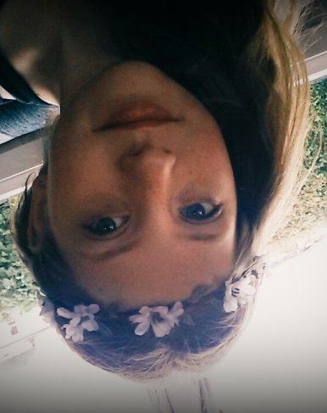
Hello, I’m Fleur. I’m twelve years old and I live in Tilburg. I live in my house with my parents and my little brother. I also have a hamster; Pip.
My hobbies are; singing, playing on my violin and playing hockey. I’m playing hockey for around 6 years now, I’m the goalkeeper of my team. I also love once upon a time (a serie).
My school is the Beatrix College, and I’m in class 2TTA1. My favourite subject at school are: Music, Biology and English. I don’t really like German. My favourite colours are; light green, light blue and lilac. My favourite music genre is slow pop (that’s pop music but then a bit slower). My favourite song is; “someone like you” from Adele.

A fact about me is that I’m really clumsy, I often fall from the stairs.

